Exercise: Building a Chatbot

**Tool**: Python

**Libraries Used**: nltk

**Sample Problem**:

Build a simple Chabot which can perform a basic conversation with a user.

**Input Type**: Utterances

**Output Type**: Chatbot response in the form of utterances

**Implementation**

**from** nltk.chat.util **import** Chat, reflections  
  
pairs = [  
 [  
 **r"my name is (.*)"**,  
 [**"Hello %1, How are you today ?"**, ]  
 ],  
 [  
 **r"what is your name ?"**,  
 [**"My name is Chatty and I'm a chatbot ?"**, ]  
 ],  
 [  
 **r"how are you ?"**,  
 [**"I'm doing good\nHow about You ?"**, ]  
 ],  
 [  
 **r"sorry (.*)"**,  
 [**"Its alright"**, **"Its OK, never mind"**, ]  
 ],  
 [  
 **r"i'm doing good"**,  
 [**"Nice to hear that"**, **"Alright :), where do you work?"**, ]  
 ],  
 [  
 **r"hi|hey|hello"**,  
 [**"Hello! What's your good name"**, **"Hey there! What's your good name?"**, ]  
 ],  
 [  
 **r"(.*) age?"**,  
 [**"I'm a computer program dude\nSeriously you are asking me this?"**, ]  
  
 ],  
 [  
 **r"what (.*) want ?"**,  
 [**"Make me an offer I can't refuse"**, ]  
  
 ],  
 [  
 **r"(.*) created ?"**,  
 [**"Aman created me using Python's NLTK library "**, **"top secret ;)"**, ]  
 ],  
 [  
 **r"(.*) (location|city) ?"**,  
 [**'Chennai, Tamil Nadu'**, ]  
 ],  
 [  
 **r"how is weather in (.*)?"**,  
 [**"Weather in %1 is awesome like always"**, **"Too hot man here in %1"**, **"Too cold man here in %1"**,  
 **"Never even heard about %1"**]  
 ],  
 [  
 **r"i work in (.*)?"**,  
 [**"%1 is an Amazing company, I have heard about it. But they are in huge loss these days."**, ]  
 ],  
 [  
 **r"(.*)raining in (.*)"**,  
 [**"No rain since last week here in %2"**, **"Damn its raining too much here in %2"**]  
 ],  
 [  
 **r"how (.*) health(.*)"**,  
 [**"I'm a computer program, so I'm always healthy "**, ]  
 ],  
 [  
 **r"(.*) (sports|game) ?"**,  
 [**"I'm a very big fan of Football"**, ]  
 ],  
 [  
 **r"who (.*) sports personality ?"**,  
 [**"Messy"**, **"Ronaldo"**, **"Roony"**]  
 ],  
 [  
 **r"who (.*) (moviestar|actor)?"**,  
 [**"Brad Pitt"**]  
 ],  
 [  
 **r"quit"**,  
 [**"BBye take care. See you soon :) "**, **"It was nice talking to you. See you soon :)"**]  
 ],  
 [  
 **r" (ok|okay) "**,  
 [**"cool"**]  
 ]  
]

**def** chatty():  
 print(**"Hi, I'm Chatty and I chat alot ;)\nPlease type lowercase English language to start a conversation. Type quit to leave "**) *# default message at the start* chat = Chat(pairs, reflections)  
 chat.converse()  
  
**if** __name__ == **"__main__"**:  
 chatty()

**Screenshot**

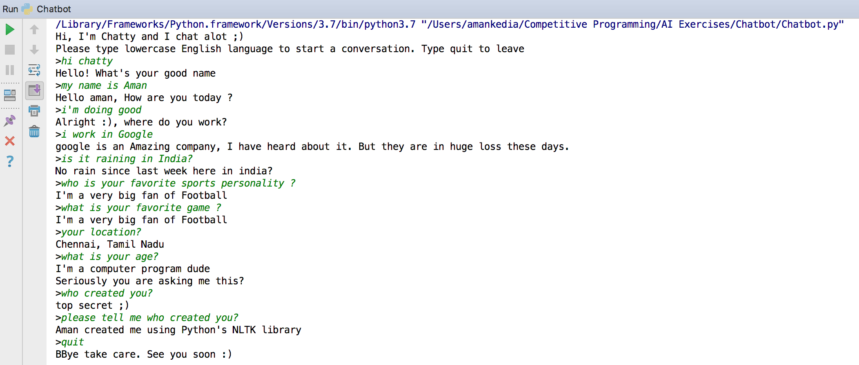

**Lab Exercise (TODO)**

1. **Add more pairs and make the Chatbot respond to complex queries.**
2. **Create your own set of reflections and build the Chabot using those.**
3. **Developing a Machine Learning based Chatbot which can respond to similar queries.**